i2s Business Solution Pte Ltd

Design and Development of Services and

Workflows on the Integration Platform of the

Next Generation Application of Essilor

*For further information please contact*

**Sujith Unnikrishnan**

**Delivery Head**



www.i2sbs.com

*Note: The contents of this proposal are considered i2s Confidential. No part of this proposal may be reproduced in any form by any means without the prior written authorization of i2s Business Solutions.*

Table of Contents

1. Executive Summary 3

2. Our Understanding 4

2.1 Objectives 4

2.2 Our Understanding of Requirements 4

2.2.1 Functional Requirements 5

2.2.2 Non-functional Requirements 6

2.2.3 Integration Requirements 6

2.2.4 Transition Requirements 6

2.2.5 Project Governance 6

3. Scope of Services 7

3.1 Scope Inclusions 7

3.2 Assumptions / Dependencies 8

3.3 Scope Exclusions 9

4. Solution Architecture 10

5. Delivery Approach 11

5.1 VF1 – Understand the scope, collect requirement, produce project plan and perform design and development for agreed scope. 12

5.2 VF2 – Support during System Integration Test (SIT) 14

5.3 VF3 – Support during User Acceptance Test (UAT) 15

5.4 VF4 – Knowledge transfer for the service developed. 16

5.5 Team Sructure 17

5.6 Proposed Timelines 18

5.7 Deliverables 18

5.8 Project Roles 19

6. Commercials 20

6.1 Delivery 20

# Executive Summary

i2s Business Solutions is a leading provider of end-to-end high quality, reliable and cost effective IT services and solutions for global companies based in Asia/Pacific, Middle-East and Africa. We thank Essilor for providing us the opportunity to engage early and demonstrate our technical capabilities on ESB solutions.

We have taken time to write this proposal in detail to showcase our interest in helping Essilor meet its objective. We have also enclosed a presentation which highlights our differentiators and customers with whom we have had great success stories.

i2s helps you to deliver your business objectives by bringing in the technology and people centric approach to delivery. i2s’ vision is to create a unique delivery model, driven by the organization’s core values, to gain customer centricity, deliver agreed-upon services and add value beyond what the customer expects.

i2s was founded in 2006 in Singapore. The company focuses on high-end, niche technical skills for transformational technologies such as Big Data, Integration, Enterprise Marketing, Business Analytics and Mobile.

i2s’ technical expertise and leadership in core and transformational technologies places the company in a unique position to deliver complex enterprise solutions. It has accordingly earned the reputation of being a high-end IT services provider. Enhanced client service levels and customer relationship are two key driving factors for the company’s success and getting repeat projects from a client, and new business from the client’s subsidiaries.

Over the last 9 years, i2s has implemented more than 2000 projects across its 55+ clients in 15 countries globally. i2s has strong capabilities in the banking and telecom industry verticals. It has a strong track-record in implementing BPM and ESB (based on SOA) projects for very large banks in Malaysia, Singapore, the Philippines, Indonesia and UAE. Our expertise in ESB implementation spans a period of 9 years since our inception.

We wish all the success for Essilor’s transformation journey and we thank you once again for this opportunity.

i2s Management Team.

# Our Understanding

## Objectives

Essilor has embarked on a strategic journey on implementing an effective and efficient Integration Platform based on IBM Integration Bus (IIB) for its Next Generation Application (NGA) to integrate its different systems, improve its capabilities to service customers faster and better and build efficient and optimized services and processes. The primary objective of bringing in an integration platform is to overcome some key challenges being faced by Essilor at the moment by introducing the following :

* Automated routing of jobs/orders to the appropriate labs with necessary transformations
* Centralized rules configuration in an external rules engine
* Automated disaster recovery
* Flexible, simplified and robust system-orchestrated processes with minimal human interventions.

## Our Understanding of Requirements

Our understanding of the requirements, based on the discussions that took place between the Essilor and the i2s teams during the requirements overview workshop, can be presented as follows. We have classified the requirements into the major categories mentioned in the table below. Each of the requirements discussed in the workshop is mapped to one of those categories.

|  |  |
| --- | --- |
| Requirement Category | Category Brief |
| Functional | This section captures in detail the high level functional requirements that are in scope. |
| Integration | This section captures the key integration requirements with the Essilor systems. |
| Non-Functional | This section captures the expectations in terms of the performance of the solution. |
| Transitions | This section captures the knowledge transfer requirements. |
| Project Governance | This section highlights the requirements surrounding the project governance – like Project Management and deliverables expected from Essilor. |

### Functional Requirements

Following are the key functional requirements:

* **Integration Services :-** Atomic services which will integrate with the different Essilor systems, transform and route messages to appropriate destinations to fulfill the below requirements.
* ECP Notification
* Heavy Calculations Request
* Heavy Calculations Response
* Job Creation
* Job Activation
* Inventory Availability Check
* Inventory Update
* Pricing & Promotions application to Orders
* Fetching Coupon Details
* Credit Control
* Job Breakage
* Partial Picking of Bulk Orders
* Job Status Update
* Modification Request
* Modification Acknowledgement
* Modification Response
* Modification Rejection Response
* Modification Request to Abandon
* Cancellation Request
* Calculation Removal Request
* Return Request
* Recall Request
* Create Lab
* Create Branch
* Create CS
* Change Order State to Saved
* Change Order State to Cancelled
* Status File Transformation and Routing
* Shipment Carton/ Dropsy Text File Transformation and Routing
* Melawai Orders Transformation and Routing
* Lab Master Orders Transformation and Routing
* Wanaxin Orders Transformation and Routing
* Galaxy Orders Transformation and Routing
* Winlinx Orders Transformation and Routing
* OPSM Orders Transformation and Routing.
* **Integration Workflows :-** Workflows which will co-ordinate activities among different Essilor systems to fulfil the below requirements.
* Order Save Workflow
* Release Order Workflow
* Dispatch Order Workflow.

### Non-functional Requirements

Our solution shall address following key non-functional areas :

* Security
* Performance
* Scalability.

### Integration Requirements

The services and workflows developed to meet the functional requirements mentioned in section 2.2.1 will integrate with the following Essilor systems :

* Rainbow (Order Capture System)
* Crimson (Order Management System)
* Hercules (Lab/Job Management System)
* Mandrake (Master Data Management System)
* ERP System
* Clapton (Calculations Engine)
* SMSC (Notification Engine)

### Transition Requirements

**Knowledge Transfer**

i2s shall ensure that effective transfer of technology and knowledge to Essilor personnel (administration and technical) occurs during the implementation to ensure that there is sufficient knowledge in the operation and maintenance of the solution.

### Project Governance

i2s shall appoint a dedicated Project Manager with extensive experience of handling integration projects who will manage the project overall and be the point of contact of/for the project team.

# Scope of Services

The scope of this project is mainly based on the requirements that were collected during the discussions between the Essilor team and the i2s team. All the requirements specified in Section 2 above are considered in the scope. In summary, the scope of this engagement can be described as below :

## Scope Inclusions

We understand the scope is to develop services and workflows for the Essilor Integration Platform and implement those.

* **Application Design & Development**
  + Design and develop 35 integration services mentioned in the previous section.
  + Design and develop 3 integration workflows mentioned in the previous section.
* **Integration Activities**
  + Integrate with the different Essilor Systems (Crimson, Hercules, Clapton, SMSC, ERP and Mandrake) for the 35 integration services identified.
  + Integrate with the different Essilor Systems (Crimson, Hercules, Clapton, SMSC, ERP, Mandrake and Rainbow) for the 3 integration workflows identified.
  + Integration with the FTP servers for importing the files into the order workflow is also within the scope.
* **Testing Activities**
  + Unit Testing of the developed services and workflows on the development environment.
  + Internal SIT for the services and workflows on the test environment.
  + The scope of support for end-to-end SIT and UAT will be limited to the integration of the services and workflows developed for the integration platform and not for end-to-end processes in Crimson, Hercules or other systems. However, these services/ workflows will be reusable in nature and can be consumed by multiple systems. SIT/UAT support will be extended for calling of these services and workflows by any system mentioned in the NGA architecture in section 4.
* **Project Management**
  + Overall project management.
  + Provide weekly status updates.
* **User Training Activities**
  + Provide knowledge transfer to Essilor’s personnel , post implementation.
* **Post-Live Activities**
  + Provide implementation support during the warranty period.

## Assumptions / Dependencies

* Essilor will be responsible for setting-up/configuring the environments, installing all necessary software and ensuring that all requisite accesses are available to the system including firewall clearances, security clearances, certificate installations, etc.
* Essilor will provide business and technical required to prepare the functional and technical requirement documents.
* Essilor will provide details of all the necessary interfaces, transformation and routing information for the services and files on the Essilor systems with which the 35 integration services and 3 workflows in the scope of this project are to be integrated before the start of the design and development phase.
* The necessary Essilor systems services/interfaces mentioned in the above point will be available for use before the start of unit testing of the integration services and workflows using those.
* Essilor systems (Crimson, Hercules, Clapton, Mandrake, ERP and SMSC) will make available services using REST/HTTP, JSON/HTTP or SOAP/HTTP protocols for integration from the services and workflows developed on the integration platform.
* There will be a SPOC from Essilor for the overall project.
* There will be a SPOC from each Essilor system (to be integrated) to provide information, test data and clarify doubts related to that system.
* The development environment to carry out development and unit testing will be available for use (with all necessary softwares installed) prior to the start of the Design and Development Phase.
* Essilor will provide a testbed (with access to the test versions of other systems like Hercules, Crimson, Mandrake, etc.) to carry out internal SIT of the services and workflows on the integration platform. This environment will be available for use (with all necessary softwares installed) prior to the end of the Design Phase of the integration project. Essilor will create and provide all necessary data to carry out the internal SIT.
* Essilor will arrange for access to the development environment over a virtual private network for the development team.
* The integration services and workflows will be developed on IBM Integration Toolkit and deployed/ implemented on IBM Integration Bus.
* Essilor will provide details of the Version Control Mechanism, etc. before the start of the design and development phase.
* Essilor will be responsible for timely review and acceptance of the delivered components. The users will be available to provide the feedback on the deliverable within 3 working days of submission. The changes/ redesign will be done more as a workshop and the key users would be available for such workshops.
* Essilor will be responsible for end-to-end functional testing, SIT and UAT/Acceptance Testing. I2s project team will support the SIT and UAT/AT.
* Essilor will implement changes in existing systems if required to support agreed requirements.
* All changes/new requests after the sign-off of the requirements document must be routed through the change management channel as change requests.
* All organization change management work will be fully under the responsibilities of ESSILOR e.g. impact analysis, change readiness assessment, organization design, communication, stakeholder management and etc. However we would provide support to ESSILOR to identify and prepare to execute the changes.
* The IIB services may directly call the ODM services instead of a Crimson service to fetch the rule. However, ODM will have to expose a proper decision service for the same with which IIB can integrate. From the orchestration flow perspective, there will be no change in the flow. Any such changes will be informed prior to signing off of the requirements document.

## Scope Exclusions

The following are considered as out of scope.

* Analysis, design, build, test, deploy, support and any other services, workflows or processes excluding the 35 services and 3 workflows mentioned in the requirements section is outside the scope.
* Integrations with systems other than Crimson, Hercules, Clapton, ERP, SMSC, Mandrake and Rainbow is outside the scope. However, the developed services and workflows can be consumed by any system which can consume web-services.
* Any work related to changing the existing backend applications or systems in ESSILOR is outside the scope.
* Configuration of the environment and installation of the necessary softwares is outside the scope.
* The impact of software or hardware upgrades from the legacy environment is not in scope.
* Load Testing/Performance Testing is outside the scope. However, i2s can provide suggestions regarding best practices for performance improvements.
* All enterprise reporting is considered as out of scope.
* Integration/Support for Service Registry and Repository is outside the scope.
* Business Activity Monitoring and Operational Analytics are outside the scope.
* Configuring/composing business rules or related artifacts on ODM are outside the scope.
* Human interactions and user interfaces are outside the scope.
* All orchestrations (except the 3 integration workflows mentioned in section 2.2.1) like order management process, lab management process, etc. are out of scope.
* Automated Disaster recovery are out of scope.

# Solution Architecture

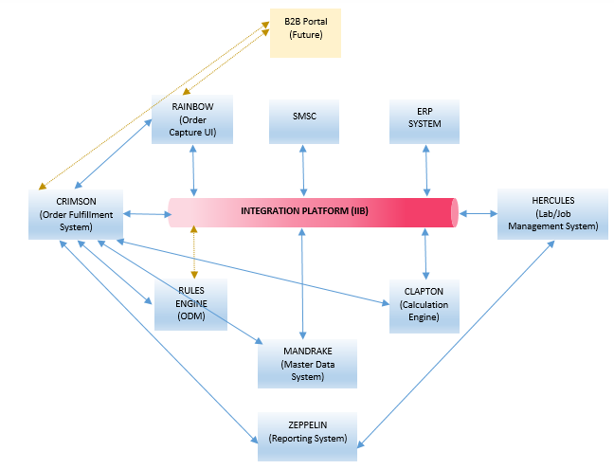The overall architecture of the NGA system will be as follows.

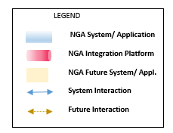

Figure I : Next Generation Application (NGA) - Overall Architecture

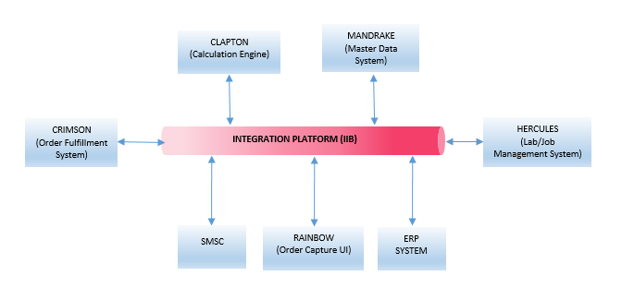The architecture of the NGA Integration Platform will as follows.

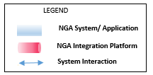

Figure II: NGA Integration Platform Architecture

# Delivery Approach

Value Frames (“VF”) deliver value in small time-bound cycles. With a VF approach, it is clear what value you will receive for specific time/cost investments. Each VF articulates clearly the activities that will be executed and deliverables. The deliverables maps to the expectation provided in the factsheet.

This project will adopt a VF based approach. The project shall consist of the following VF:

VF1 – Understand the scope, collect requirement, produce project plan and perform design and development for agreed scope.

VF2 – Support during System Integration Test (SIT)

VF3 – Support during User Acceptance Test (UAT)

VF4 – Production Cut Over or Go Live support.

VF5 -- Knowledge transfer for the service developed.

## VF1 – Understand the scope, collect requirement, produce project plan and perform design and development for agreed scope.

In this activity, i2s will complete the requirements gathering with the Essilor team, perform the scoping excerise during the requirement gathering. Prepare the development environment at the offsite and perform design and development in the iterative development approach. Upon completion of each development will be followed with internal SIT and share SIT completion report for that Particular Iteration.

This will include:

* Perform the requirement gathering excerise along with Essilor.
* Perform the detailed scoping while gathering the requirement.
* Perform the installation of IIB installation on DEV environment at the offsite.
* Ensure the connectivity testing with Essilor Dev, UAT environments.
* Perform the Design and Development of agreed requirement along with priorities of services in Iterative approach.
* Prepare the documentation for High Level and Low Level design documents and will be shared with Iterative approach. This will be living design document which gets updated Iteration by Iteration till the completion of the project.
* Perform unit testing for the Services.
* Perform the internal system integration testing for the services.
* Share the SIT completion report to Essilor.
* Any change in agreed functionality or requirement should follow change request processing adhering to Change Control Board.

**i2s Responsibilities:**

i2s will perform Services which include the following tasks:

* Perform requirement gathering and Scoping excerise.
* Preparation of the Development environment at offsite.
* Perform connectivity testing for DEV, UAT Essilor environments.
* Preparation of High and Low level Design documentation.
* Perform internal SIT and share the SIT completion reports for each Iterations.
* Share the project management, communication and stakeholder plan.
* Share the status report of the project progression to Customer.

**Customer Responsibilities:**

To facilitate timely and effective completion of this VF we require to commit to the following:

* Provide a (SPOC) single point of contact to help i2s during the discussions, by setting up the required sessions.
* Provide required access to systems to view and understand the systems which needs to be integrated.
* Provide iterative review on the requirements gathered and baseline the requirement and scope.
* Provide concurrence on the Project Management, Communication and Stakeholder plan.
* Provide the key stakeholder for change control board for acceptance and denial of change management.
* Provide all the dependencies requirement, tools and deliverables to i2s during the integration touch points testing.
* Coordinate on the risk mitigation and corrective action as and when deem necessary.
* Share overall project timelines and dependenices very clearly.
* Customer to share the escalation matrix from Essilor.
* Should provide the relevant data for each service during the development and Internal SIT testing.
* I2s will be sharing the IIB services in Iteration fashion and those service can be integrated with Essilor sprint and perform PRE-SIT testing with all interfaces.
* Database environment and credentials details will be shared with i2s.

**Deliverable Materials:**

The deliverables for this VF are:

* Project Management Plan (Microsoft project plan), Progress report (Word Documentation), communication and Stakeholde plan.
* Design Documentation (HLD and LLD).
* SIT test plan, Test scenario and test cases and SIT completion report.

**Estimated Duration:**

The duration of this VF is for each Iteration is planned for 4 weeks. Based on the current requirement and services shared will have 5 Iteration is 20 weeks.

**Assumption:**

Each Iteration will be having shippable services to the Customer.

**Completion Criteria:**

This VF is considered complete when the SIT completion report having no critical or Major defects.

## VF2 – Support during System Integration Test (SIT)

The objective of this activity is to perform SIT support of IBM IIB application to rectify if any defects encountered while or during the SIT testing. This value frame is targeted to support during the customer integration touch points testing and ensure there are no open defects from the i2s deliverables.

**i2s Responsibilities:**

The main activities within this VF are:

* Support during the SIT execution for any defect rectification on IBM IIB services deliverables.

**Severity:**

i2s shall use the following convention in raising defects during system integration testing

|  |  |  |
| --- | --- | --- |
| Severity Level | Description | Example |
| 1 | System Failure. No further processing is possible. | Critical to application availability, results, functionality, performance or usability. |
| 2 | Unable to proceed with selected function or dependants. | Application sub-system available, key component unavailable or functionally incorrect and workaround is not available. |

**Customer Responsibilities:**

To facilitate timely and effective completion of this task we require the following commitment from Customer:

* Customer shall provide i2s with login credentials to the defect tracking system for defect reporting and tracking. If no system is used, we will use spreadsheets to track the defects and do reports.
* Provide all required access to customer development and test (SIT) environments
* Provide and / or generate sample data that will be used in this Value Frame.
* Establish connectivity and provide access to dependent systems
* Do any migration/data upload into the backend systems that would participate in the integration testing
* Perform SIT execution and share the SIT completion report.
* Perform performance, scalability and any security testing.

**Deliverable Materials:**

The deliverables for this VF are:

* SIT Issue Log / Defect Resolution Reports

**Estimated Duration:**

The activities above will take approximately 4 Week of support activity during the SIT testing.

**Completion Criteria:**

SIT completion report from customer after the successful completion of SIT and perform deviation stratergy on open defects to proceed to next phase.

## VF3 – Support during User Acceptance Test (UAT)

i2s shall support Customer in completing user acceptance testing – UAT

**i2s Responsibilities:**

The main activities within this VF are:

* Provide support during UAT execution
* Fix any IIB services related defects during UAT execution.

**Customer Responsibilities:**

To facilitate timely and effective completion of this task we require Customer to commit to the following:

* To provide test scenarios that needs to be executed as part of the acceptance testing.
* Do any migration/data upload into the backend systems that would participate in the acceptance testing
* Must own, manage and execute the scenarios that have been identified for the UAT
* Whenever needed, perform sanity testing on the code, prior to including them for UAT retesting
* A daily status report of the number of test cases executed and the defects that were identified should be shared with i2S.

**Deliverable Materials:**

The deliverables for this VF from i2s

* UAT Defects related to IIB services should be fixed and provide the defect resolution report.

**Estimated Duration:**

The activities above are estimated to take up to 4 Week to UAT completion.

**Completion Criteria:**

UAT completion report signifies the successful completion of SIT and perform deviation stratergy on open defects before proceeding to next phase

## VF4 – Production Cut Over or Go Live support.

i2s shall support during the production cut over.

**i2s Responsibilities:**

The main activities within this VF are:

* Provide support during production cut over.
* Sanity testing will be performed on the IIB services.

**Customer Responsibilities:**

To facilitate timely and effective completion of this task we require Customer to commit to the following:

* Perform production infrastructure readiness.
* Perform production deployment for all the interfaces.
* Perpare the sanity test scenario and test cases for all the interface.
* Perform the sanity testing for all integrated environment.
* Do any migration/data upload into the backend systems that would participate in the acceptance testing
* Must own, manage and execute the scenarios that have been identified for the Go Live

**Deliverable Materials:**

**N/A.**

**Estimated Duration:**

The activities above are estimated to take up to 1 Week to UAT completion.

**Completion Criteria:**

Production Sign off.

## VF5 – Knowledge transfer for the service developed.

The purpose of this activity is to provide knowledge transfer on IBM IIB design and one implementation of services to Customer.

**i2s Responsibilities:**

i2s will perform Services which include the following tasks:

* Provide the knowledge transfer on IBM IIB services on Design and Implementation of one service.

**Customer Responsibilities:**

To facilitate timely and effective completion of this task we require Customer to commit to the following:

* To ensure necessary infrastructure is arranged for the training, which includes, not limited to, workstations, facilities and required access.

**Estimated Duration:**

The activities above are time boxed for not more than 3 days.

## Team Sructure

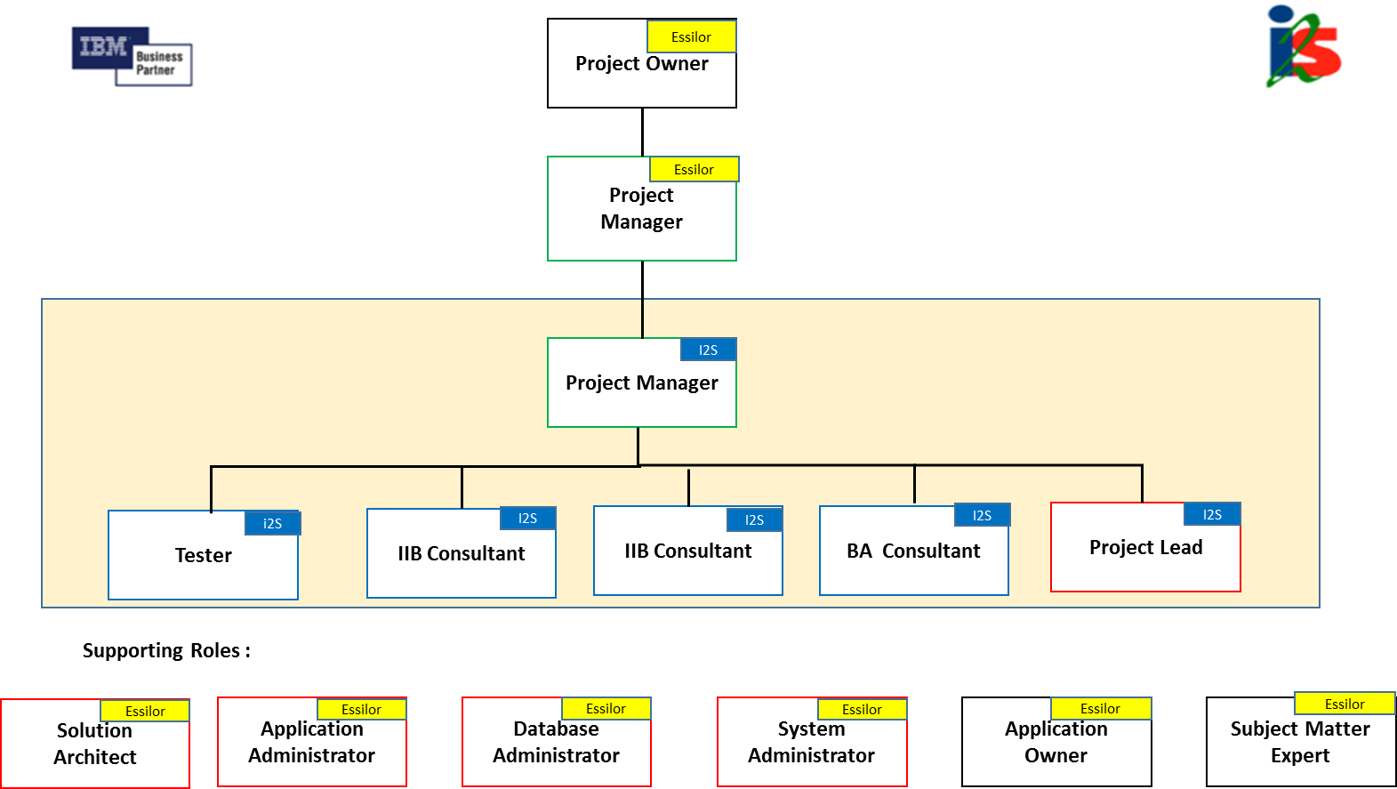

The supporting roles are illustrative and most of the customer responsibilities are outlined in the VF with greater clarity and detail.

* Application Owner – We need application owner details for each interfacing system and departments. This is to ensure they are informed and are accountable for the integration requirements.
* Application Administrator – i2s team will require access to the systems to perform testing.
* Database Administrator – This will involve providing access, creating scripts and performing day-day operational routine.
* System Administrator – This role involves providing logistics support to i2s team – Internet, Access to Floors, Conference Facility.
* Subject Matter Expert – This role involves providing the business explaination and any business rules where ever deem necessary.
* Solution Architect – This role is primary responsible for overall architecture solution, integration touch points and performance architecture. I2s team requires architecture solution and gudieness while tweaking the performance in accordance with business service requirement.

## Proposed Timelines

Please find the proposed timelines for each iteration and details of iterations duration will be captured in Microsoft Project plan.

|  |  |  |
| --- | --- | --- |
| 1Iterations | No Of Services | Weeks |
| Iteration 1 | **8** | **4** |
| Iteration 2 | **8** | **4** |
| Iteration 3 | **8** | **4** |
| Iteration 4 | **8** | **4** |
| Iteration 5 | **6** | **4** |
|  | **38** |  |

## Deliverables

|  |  |  |  |
| --- | --- | --- | --- |
| **Deliverable** | **Phase** | **Essilor** | **i2s** |
| Overall Project/Program Plan | Plan & Start Up | X |  |
| Detailed Project Plan | Plan & Start Up |  | X |
| Hardware Sizing and Related documents | Analysis & Design | X |  |
| Overall Architecture Document | Analysis & Design | X |  |
| Functional & Technical Requirements Document | Analysis & Design |  | X |
| Integration Design Document | Analysis & Design |  | X |
| Low Level Design Document | Analysis & Design |  | X |
| Software Code for the 35 Integration Services & the 3 Integration Workflows | Configure & Deploy |  | X |
| Test Plan & Test Cases – Unit Testing, SIT (Limited to the Services and Workflows on the Integration Platform) | Configure & Deploy |  | X |
| Cutover Plan, Rollback Plan | Operate | X | X |
| User’s Handbook/Guidelines & Hand-over Document | Operate |  | X |
| Weekly Status Meetings & Project Governance | All | X |  |
| Platform Installation & Documentation | Configure & Deploy | X |  |
| Pre & Post Go-Live Verification Document | Configure & Deploy | X |  |

## Project Roles

|  |  |
| --- | --- |
| **Role** | **Description** |
| Project Manager | PM to manage i2s deliverables and customer interactions. |
| Business Analyst | Analyst to help capture the initial requirements and translate those for the technical team. |
| Project Lead | Single point of contact for the development team. |
| IIB Consultants | Consultants will be responsible for the low-level design and development of services/workflows in IIB. Consultants will also support the SIT and UAT done by the Essilor team. |
| Tester | Technical testers will be responsible for verifying the developed services and workflows during internal SIT. |

# Commercials

The costs and the payment milestones are given in the table below. These costs are based on the scope of work and deliverables as described in this proposal.

## Delivery

The below mentioned costs are not inclusive of GST.

|  |  |  |
| --- | --- | --- |
| **Milestone** | **%** | **Amount SGD** |
| Contract Sign off | 20% | 125,672 |
| Design, Development and Internal SIT | 50% | 314,179 |
| SIT Support | 10% | 62,836 |
| UAT Support | 10% | 62,836 |
| Go Live | 10% | 62,836 |
| Total | SGD | 628,358 |
| *4 weeks for warranty support after Go Live.  Assumption: Go Live will happen end of this year 2015 + 2 months. | | |